**Object DETECTION MODEL FOR WOODEN PIECES**

**# PROBLEM STATEMENT:**

**Given unlabeled images of wood slices (i.e. sections) in the data folder, create a ML model to identify and segment anomalies (i.e.knots, spots, etc).**

**DATASET:**

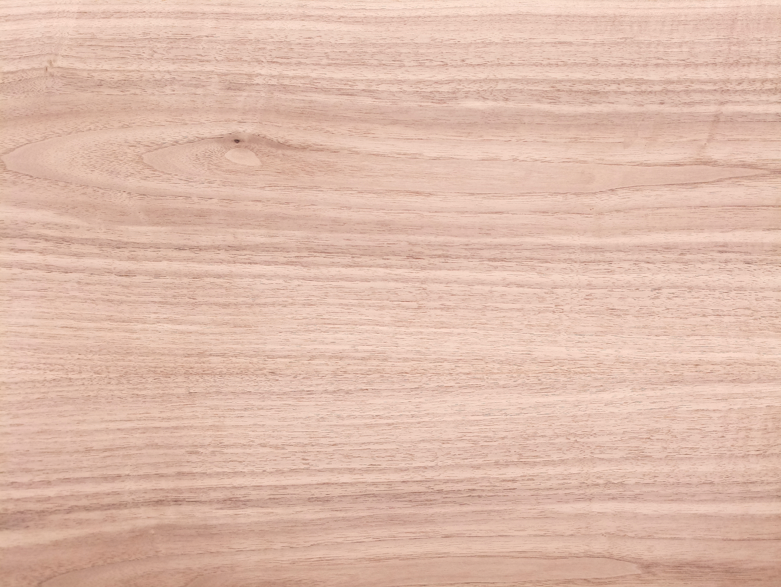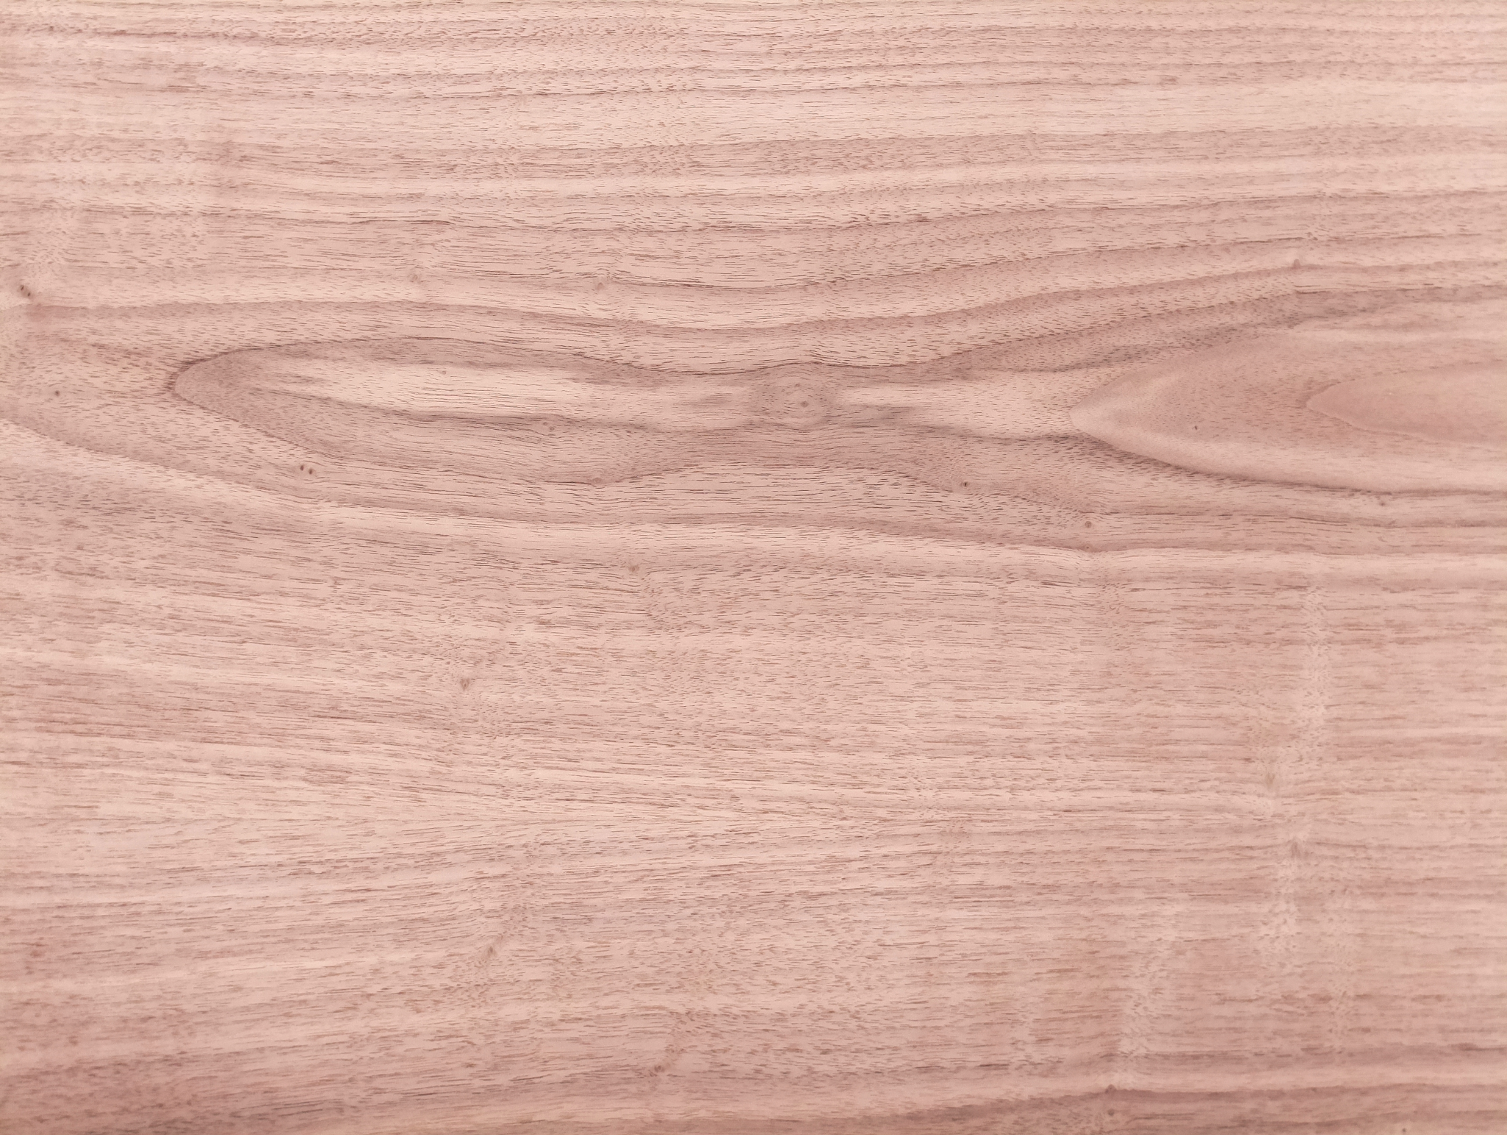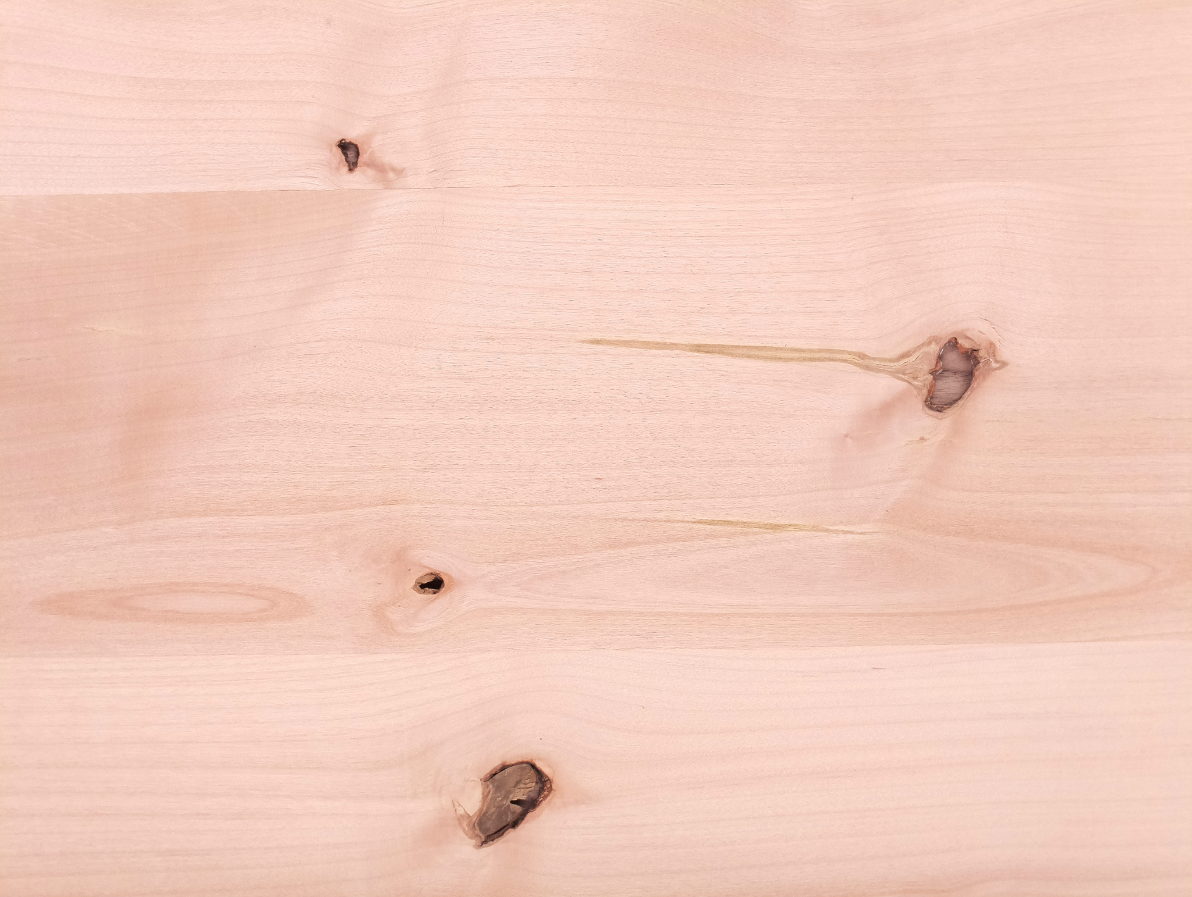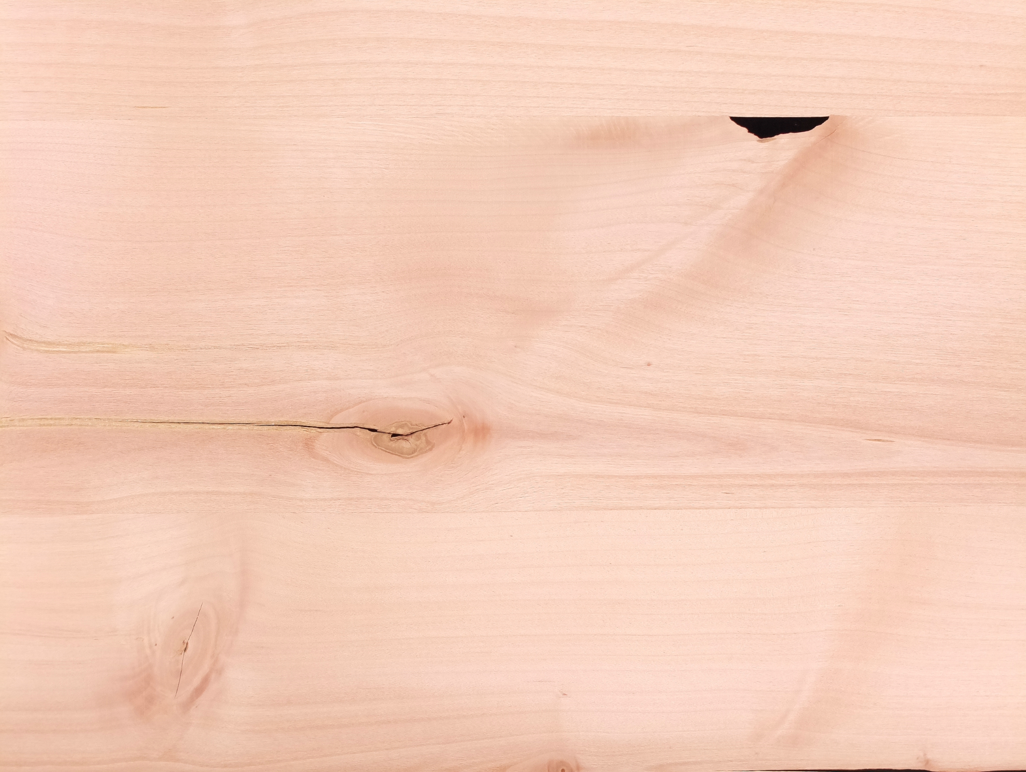

**SOLUTION:**

Before heading towards the solution we have to analyze the data thoroughly. It's very important to identify the target objects and the challenges.

In a real world application, I would say that the following problem statement should not be treated as unsupervised learning, the anomalies are pretty obvious and can be expected.

A set of training data with labels can quickly be built and an object detector can be trained with large accuracy.

Following steps were taken to handle the problem:

1. **Data Augmentation**

Data augmentation is done using keras image data generation module.

datagen =**ImageDataGenerator**(rotation_range=30,width_shift_range=0.5,

height_shift_range=0.5,shear_range=0.30,zoom_range=0.5,

horizontal_flip=True,brightness_range=(0,0.4),

featurewise_center=False, samplewise_center=False, featurewise_std_normalization=False, samplewise_std_normalization=False,

zca_whitening=False, zca_epsilon=1e-06,

fill_mode='nearest', cval=0.5, vertical_flip=True, validation_split=0.1)

1. **Synthetic Data Generation**

Some of the data was generated synthetically by extracting the required objects and background from the dataset provided and then creating synthetic data.

<https://github.com/tylerhutcherson/synthetic-images> was utilized to create a data.

Note:

Variational autoencoders can also be utilized to create synthetic data to improve the accuracy more.

1. **Annotating The Images**

LabelIMG was utilized to annotate the required images. There is just one class and defects are named as “knots”.

1. **Training Object Detection Model**

**YOLOv3** was trained with the dataset created in step 2-3.

Training Curve:

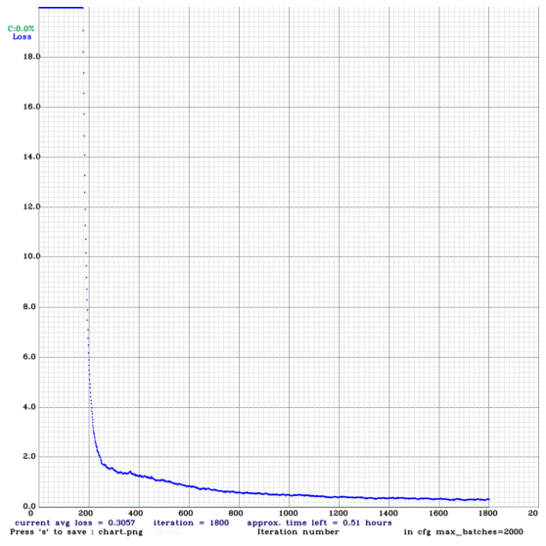

1800: 0.284915, 0.305728 avg loss, 0.000010 rate, 3.719886 seconds, 115200 images, 0.513898 hours left

The final loss was around 0.28 which I ran for 1800 iterations. I have to stop the training to get the results ready. However, if the model was continued to run, loss can be reduced further.

1. **Testing**

**Predicted in 40.237000 milli-seconds**

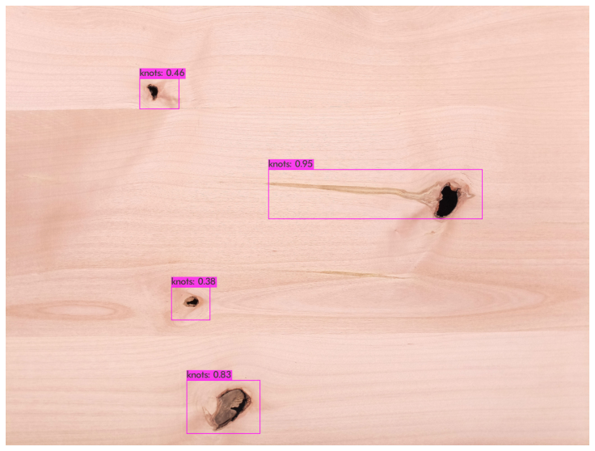

Predicted in 40.306000 milli-seconds

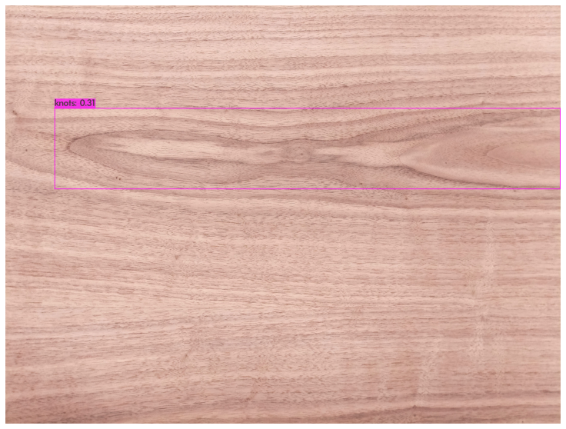

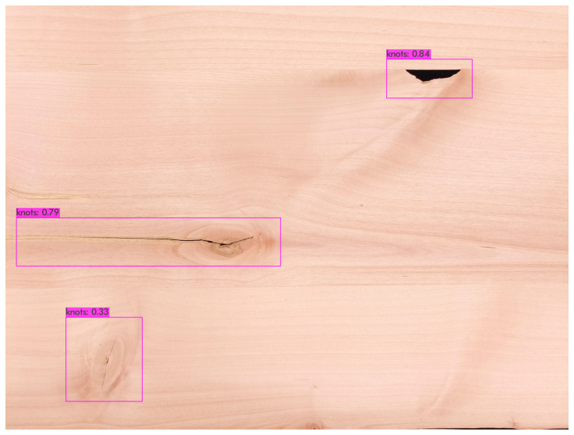

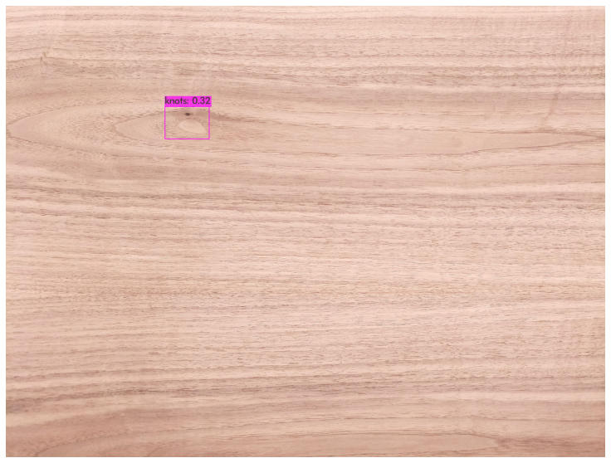

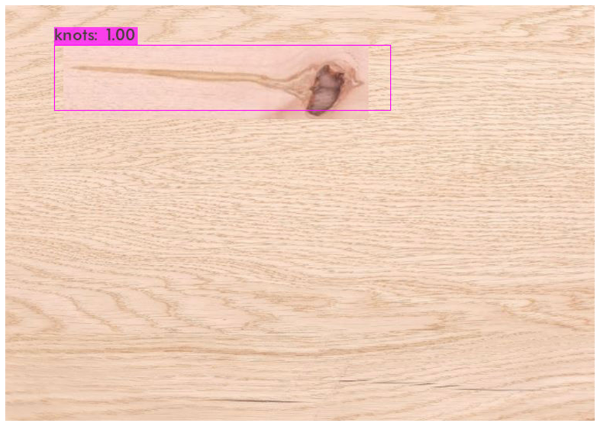

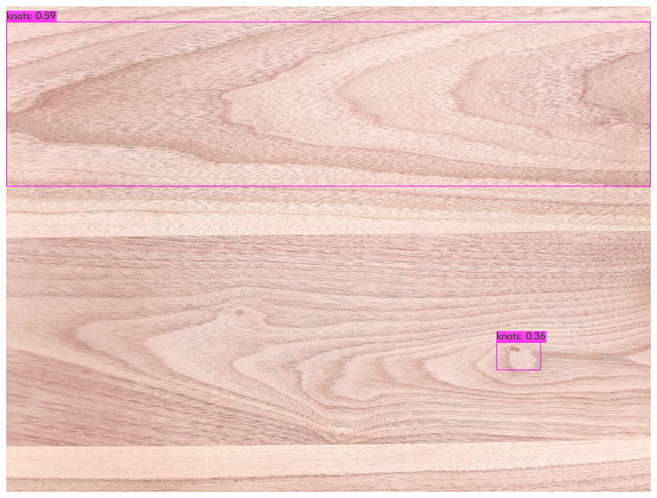

**Improvement:**

1. Though model performance is good in all testing dataset. The performance can further be increased by using real world dataset.
2. Creating more synthetic data using VAE.
3. Training the model until the loss is reduced below 0.1.
4. I was also interested to look at the image semantic segmentation approach that might be helpful.
5. Morphological transformations were not added while preprocessing that could be helpful too.
6. Transfer learning can also be helpful to improve accuracy.
7. Faster RCNN usually works very well if optimization is not required.
8. The model can achieve a better accuracy with tuning hyperparameters.
9. Also sensor fusion with 2 models can help the accuracy further.

**TO RUN THE APPLICATION:**

1. To run the application kindly please copy yolov3 from the folder to your root directory , run YOLOv3_Object Detection.ipynb.
2. You can save a few testing images in the yolov3 directory to run the code with desired testing data.